Executive Summary 2
Introduction 3
Outlook of solution 3
Interface guidelines 3
Problem Analysis 4
Goals 4
Assumptions 4
Simplifications 5
Object Design 6
Candidate Classes 6
Discarded Classes 6
Design Justification 6
Class Diagram 8
CRC Cards 8
Design Quality 15
Design Heuristics 15
Design Patterns 16
Bootstrap Process 17
Verification 19
Pre-book a slot and pay for booking 19
Park vehicle 20
Pay for walk-in 21
View parking lot statistics 22
Appendix 23

Executive Summary
SmartParking is a business that provides paid parking facilities for cars and motorbikes on Duy Tan Street. The current setup requires drivers to find and pay for their parking spots in person when they arrive, which can lead to extended waiting periods and the risk of not being able to find a parking slot. To address this issue, SmartParking’s owners are planning to introduce an Online Smart Parking Space (OSPS). This system will allow customers to reserve parking spaces online and manage bookings, payments, and parking directions. For the owners, it offers improved administration of the parking areas.
In this report, we will delve deeper into the given case study by showcasing an initial object-oriented design for the system. After identifying and justifying all the candidate classes for our solution, we will develop the CRC card design. This will provide a brief description of each class, its responsibilities, and the collaborators required for each responsibility. Following this, the report will illustrate any Design Patterns or Design Heuristics that have been used in the initial design, providing reasons for their inclusion. Lastly, to verify the design, four typical, non-trivial interaction patterns or scenarios are presented, which will help demonstrate how the system determines the validity of user input and how it applies to specific business activities or processes.

Introduction
This document describes the analysis used to determine the classes, interfaces, and guidelines required for the system. It serves as a resource for developers, managers, and customers to share information about system design and future testing.

Outlook of solution
The proposed solution involves carefully planning the roles and interactions of different parts of the Online Smart Parking Space (OSPS). By using Responsibility-Driven Design, we aim to clearly define what each part of the system should do and how they should work together. This design is built to be flexible, scalable, and modular, meaning it can easily be expanded or modified in the future. We have utilized tools like class diagrams and CRC cards to visually show and describe the system's components, making it easier for stakeholders to understand the design. This approach is intended to create a robust, efficient and applicable OSPS.

Interface guidelines
The following table describes the naming convention we use for various programming constructs in this document.
Type | Convention | Example
Classes | PascalCase | MyClass
Objects | camelCase | myObject
Functions or methods | camelCase | myFunction()
Properties, attributes, or parameters | camelCase | myProperty

Problem Analysis

Goals
The goal of this project is to devise a preliminary object-design for the online smart parking system (OSPS) as per the Requirement Specification document (see Appendix). The design is expected to support the functions and quality attributes defined therein, which are:
F1 Create driver account
F2 Update driver account
F3 Pre-book a parking slot
F4 Change a booked slot
F5 Park vehicle
F6 Pay for booking
F7 Pay for walk-in
F8 View booking statistics of the parking lot
F9 Change existing parking slot
F10 Add a new parking slot
And:
Q1 Security
Q2 Performance
Q3 Scalability
Q4 Usability
Q5 Portability

Assumptions
On top of the assumptions listed in the Requirement Specification (see Appendix), the design described in this document makes a number of additional assumptions about the system, which are:
A1 SmartParking is not interested in saving detailed information about the vehicles that arrive at the parking lot, except for their license plate number.
A2 The information of walk-in drivers does not have to be saved.
A3 Only one vehicle can park in a slot at any given time.
A4 Walk-in drivers must confirm their departure time on arrival.
A5 Currently, the owners of SmartParking are only interested in monitoring revenue and frequency data and they would like to see it displayed in paper, Excel, or web format. However, the system will be designed to easily support more data types and formats in the future.
A6 The system operates on a database, which is not mentioned in the design at this level. It is implicitly understood that classes will interact with the database to fetch and save data as needed.

Simplifications
Based on the assumptions described above, the design has made a number of simplifications on the class hierarchy, which are:
S1 The only relevant piece of information related to vehicles is their license plate numbers. As such, no separate Vehicle class is needed, and this information can be an attribute of ParkingSession.
S2 The Driver class represents a driver who has registered an account on the system who can pre-book slots. Walk-in drivers are not represented by this class or any other class.

Object Design

Candidate Classes
- User
  - Admin
  - Driver
- ParkingLot
- Slot
- ParkingSession
- ParkingInterval
- Invoice
- Payment
  - CashPayment
  - OnlinePayment
    - CreditPayment
    - OnlineBankingPayment
- Report
  - PaperReport
  - ExcelReport
  - WebpageReport
- ReportData
  - RevenueData
  - FrequencyData

Discarded Classes
- Booking
- SlotType
- Receipt

Design Justification
After carefully considering which classes to include in the design, we have come up with the complete candidate class list. Here is a brief explanation of why those classes should be chosen:
- ParkingLot, Slot, ParkingSession, and ParkingInterval play a role in the parking and booking process. In general, they keep track of the availability of parking slots and allocate drivers to their slots respectively.
- Invoice and Payment help to handle all the payment processes in the system. We have specialized Payment into smaller classes to take advantage of polymorphism. CashPayment, CreditPayment, and OnlineBankingPayment can all be treated as a Payment in our system.
- Report and ReportData help the owners to monitor the parking lot data, namely RevenueData and FrequencyData, and display it. Based on the needs of the admin, we can choose one of three Report types: PaperReport, ExcelReport, or WebpageReport.
Besides the chosen candidate class, we also discard some classes:
- The Booking class was originally designed to track user bookings, such as time and slot. However, we have decided to merge it with the ParkingSession class, which can keep track of both the booking and the parking session of the driver.
- SlotType only stores the vehicle type of each slot, so it is not necessary to make it a separate class in the system. It can instead be an attribute of Slot.
- Receipt was originally included in the domain model and we initially considered this class. However, as Payment and its subclasses have all the payment-related information and are more or less a representation of Receipt, we have decided to exclude this class.

Class Diagram
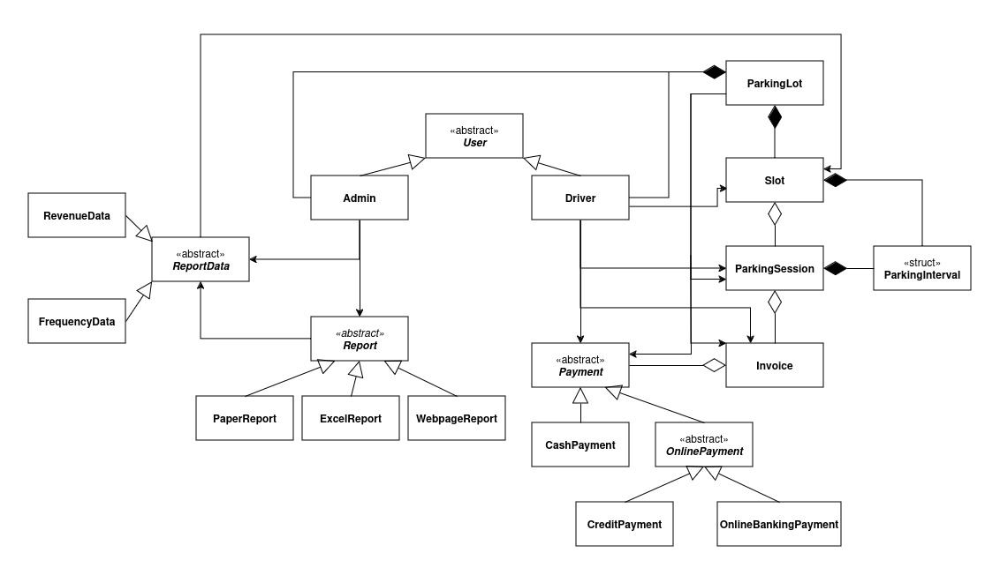
Fig. 1: The UML class diagram of the design.

CRC Cards
The following describes each class in the above diagram in detail, including their responsibilities in the system and collaborations with other classes.
Class name: User
Parent class(es): None
Description: An abstract class which captures the key abstractions of a User in the system. It can be specialized into 2 other classes which are Driver and Admin.
Responsibilities | Collaborators
Knows information related to a user such as name, age, etc. | None
Knows credentials related to a user. | None

Class name: Admin
Parent class(es): User
Description: This class represents an admin account. Admins can manage the parking slots as well as monitor parking statistics.
Responsibilities | Collaborators
Knows ID. | None
Can request report data. | ReportData
Can create a report based on the report data. | ReportData, Report

Class name: Driver
Parent class(es): User
Description: This class represents a driver account. Drivers can pre-book slots.
Responsibilities | Collaborators
Knows ID. | None
Knows its parking sessions. | ParkingSession
Knows its payments. | Payment
Can pre-book parking slots. | Slot, ParkingSession, Invoice, OnlinePayment

Class name: ParkingLot
Parent class(es): None
Description: Represents the whole parking lot. This class acts similar to the Main class, whose responsibilities is to keep track of many aspects of the parking lot and initialize the system on startup.
Responsibilities | Collaborators
Knows its slots. | Slot
Knows its drivers. | Driver
Knows its admins. | Admin
Can modify slots’ information. | Slot
Can create walk-in parking sessions. | ParkingSession, Invoice, CashPayment
Can initialize the system. | Slot, Driver, Admin

Class name: Slot
Parent class(es): None
Description: This class represents a single slot in the parking lot. A slot is aware of when it is occupied.
Responsibilities | Collaborators
Knows the time intervals in which it is occupied. | ParkingInterval
Knows its type. | None
Knows its location. | None
Can check its availability for a given time period. | ParkingInterval

Class name: ParkingSession
Parent class(es): None
Description: This class represents the booking or parking session for a slot.
Responsibilities | Collaborators
Knows its slot. | Slot
Knows its parking interval. | ParkingInterval
Can be confirmed, which marks the chosen slot as occupied. | Slot
Can be freed, which marks the chosen slot as available. | Slot
Can calculate the parking cost. | Slot

Class name: ParkingInterval
Parent class(es): None
Description: A data class with only two time values that specify the arrival and departure time of a parking session.
Responsibilities | Collaborators
Knows its arrival and departure time. | None

Class name: Invoice
Parent class(es): None
Description: Represents an invoice for a given ParkingSession, which informs the user of the amount of money that they have to pay.
Responsibilities | Collaborators
Knows its parking session. | ParkingSession
Knows the amount of money to be paid. | None

Class name: Payment
Parent class(es): None
Description: Abstract class for the different payment methods.
Responsibilities | Collaborators
Knows the invoice to be paid for. | Invoice

Class name: CashPayment
Parent class(es): Payment
Description: Represents a physical cash payment made when a walk-in driver leaves the parking lot.
Responsibilities | Collaborators
Can calculate the change to return to the driver. | Invoice

Class name: OnlinePayment
Parent class(es): Payment
Description: An abstract class for 2 different online payment methods.
Responsibilities | Collaborators
Can withdraw a given amount of money from an external party. This method must be implemented by the subclasses. | None

Class name: CreditPayment
Parent class(es): OnlinePayment
Description: Represents a credit card payment made when a registered driver books a slot or a walk-in driver leaves the parking lot.
Responsibilities | Collaborators
Knows the details of the credit card. | None
Can withdraw from the credit card balance. Implements the withdrawal function of OnlinePayment. | None

Class name: OnlineBankingPayment
Parent class(es): OnlinePayment
Description: Represents an online banking payment made when a registered driver books a slot or a walk-in driver leaves the parking lot.
Responsibilities | Collaborators
Knows the details of the bank account. | None
Can withdraw money from the bank account balance. Implements the withdrawal function of OnlinePayment. | None

Class name: Report
Parent class(es): None
Description: Abstract class for the different report formats.
Responsibilities | Collaborators
Knows the report data. | ReportData
Can format the report data into a viewable form. This method must be implemented by the subclasses. | ReportData

Class name: PaperReport
Parent class(es): Report
Description: Represents the paper report format.
Responsibilities | Collaborators
Knows the report data. | ReportData
Can format the report data into a paper report. Implements the formatting function of Report. | ReportData

Class name: ExcelReport
Parent class(es): Report
Description: Represents the Excel report format.
Responsibilities | Collaborators
Knows the report data. | ReportData
Can format the report data into an Excel report. Implements the formatting function of Report. | ReportData

Class name: WebpageReport
Parent class(es): Report
Description: Represents the webpage report format.
Responsibilities | Collaborators
Knows the report data | ReportData
Can format the report data into a web page report. Implements the formatting function of Report. | ReportData

Class name: ReportData
Parent class(es): None
Description: Abstract class for the different types of report data that SmartParking is interested in.
Responsibilities | Collaborators
Knows the start and end dates of the data of interest. | None
Knows the slots of interest. | Slot
Can query the report data from an external source. This method must be implemented by the subclasses. | Slot
Can process the report data based on different rules. This method must be implemented by the subclasses. | None

Class name: RevenueData
Parent class(es): ReportData
Description: Represents the revenue data of the parking lot. Can be given start and end dates and slot information to limit the search.
Responsibilities | Collaborators
Knows the start and end dates of the data of interest. | None
Knows the slots of interest. | Slot
Can query the report data from an external source. Implements the fetching function of ReportData. | Slot
Can process the report data based on different rules. Implements the processing function of ReportData. | None

Class name: FrequencyData
Parent class(es): ReportData
Description: Represents the frequency data of the parking lot. Can be given start and end dates and slot information to limit the search.
Responsibilities | Collaborators
Knows the start and end dates of the data of interest. | None
Knows the slots of interest. | Slot
Can query the report data from an external source. Implements the fetching function of ReportData. | Slot
Can process the report data based on different rules. Implements the processing function of ReportData. | None

Design Quality

Design Heuristics
The following design heuristics have guided the design process. They have been quoted directly from the book Object-Oriented Design Heuristics by Arthur J. Riel.
Heuristic 1: A class should capture one and only one key abstraction.
Heuristic 2: Keep related data and behavior in one place.
Heuristic 3: Be sure the abstractions that you model are classes and not simply the roles objects play.
Heuristic 4: Distribute system intelligence horizontally as uniformly as possible.
Heuristic 5: Do not create god classes/objects in your system.
Heuristic 6: Eliminate irrelevant classes from your design.
Heuristic 7: Eliminate classes that are outside the system.
Heuristic 8: Do not turn an operation into a class.
Heuristic 9: Minimize the number of classes with which another class collaborates.
Heuristic 10: If a class contains objects of another class, the containing class should send messages to the contained objects.
Heuristic 11: Inheritance should be used only to model a specialization hierarchy.
Heuristic 12: Derived classes must have knowledge of their base class by definition, but base classes should not know anything about their derived classes.
Heuristic 13: Inheritance hierarchies should be no deeper than an average person can keep in their short-term memory.
Heuristic 14: All abstract classes must be base classes.
Heuristic 15: All base classes should be abstract classes.
Heuristic 16: Factor the commonality of data, behavior, and/or interface as high as possible in the inheritance hierarchy.
Heuristic 17: If two or more classes have common data and behavior, they should each inherit from a common base class.
Heuristic 18: If two or more classes share only a common interface, they should inherit from a common base class only if they will be used polymorphically.
Heuristic 19: It should be illegal for a derived class to override a base class method with a NOP method.
Heuristic 20: When given a choice between a containment relationship and an association relationship, choose the containment relationship.

Design Patterns
Singleton Pattern:
Usage: ParkingLot
Justification: Ensures that only one instance of the ParkingLot exists, providing a single point of control for system operations. This pattern is crucial for managing shared resources consistently.
Strategy Pattern:
Usage: OnlinePayment, Report.
Justification: Using Strategy Pattern on OnlinePayment allows the system to switch between different payment methods dynamically. The Payment class uses different strategies, namely CreditPayment and OnlineBankingPayment to process payments, making the system flexible and extensible. This pattern can also be used for Report class as it can shift between ExcelReport, PaperReport and WebPageReport based on the requirement of the admin.
Template Method Pattern:
Usage: ReportData
Justification: Defines the skeleton of an algorithm in the superclass but lets subclasses override specific steps of the algorithm. The ReportData class uses this pattern to allow different report data types (RevenueData, FrequencyData) to implement specific steps of the data fetching process while maintaining a common structure.

Bootstrap Process
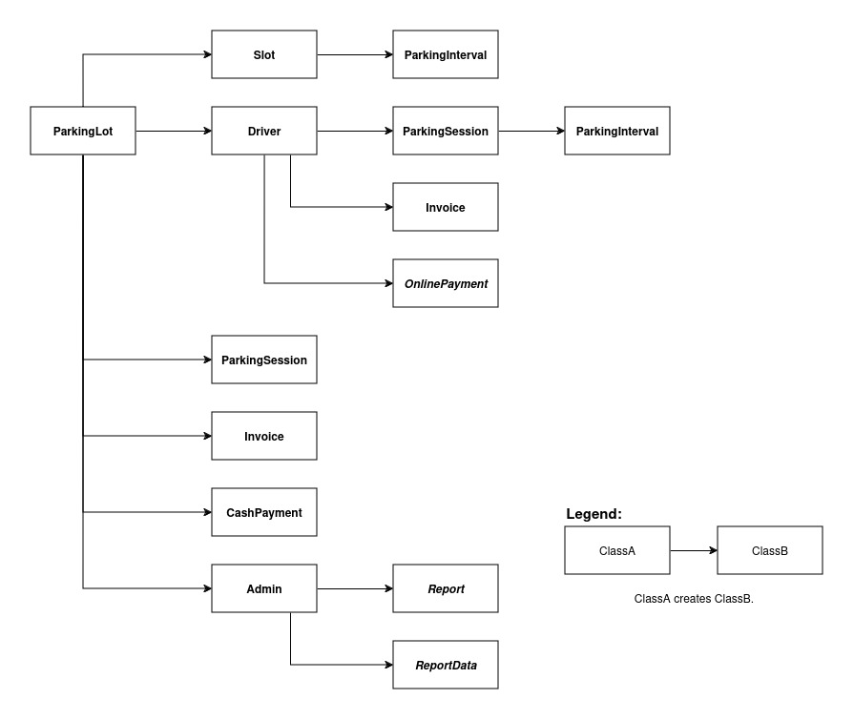
Fig. 2: The bootstrap process.
The bootstrap process of the design is reflected in the above image. It is designed to fully support the functional requirements defined in the Appendix and goes as follows:
- On startup, the ParkingLot class is created first by the executing process. This process could be something similar to the main() method.
- The ParkingLot class then initializes the system by creating instances of the Slot, Driver, and Admin classes. It is assumed that the data needed to populate these instances comes from a database, although it is not included in the diagram.
- During the execution of the system, the ParkingLot, Driver, and Admin instances can create instances of other classes.
- To keep track of the time periods in which it is occupied or booked, a Slot instance can create instances of the ParkingInterval data class.
- To allow driver accounts to be added and updated (tasks 1.1 and 1.2), ParkingLot can add or update instances of Driver as needed.
- To support the task of pre-booking and paying for booked slots (tasks 1.3 and 1.6), a Driver can create a ParkingSession, an Invoice, and an instance of one of OnlinePayment’s subclasses to cover the Invoice.
- To allow bookings to be updated (task 1.4), an instance of Driver can update or remove their ParkingSession instances as needed.
- To accommodate walk-in drivers and record their payment in the system (tasks 1.5 and 1.7), ParkingLot can create a ParkingSession, an Invoice, and a CashPayment for this session.
- To enable the owners of SmartParking to view the lot’s statistics (task 2.1), an Admin first creates an instance of one of ReportData’s subclasses. To format the data, it then creates an instance of one of Report’s subclasses, passing it the ReportData.
- To allow slots to be added and updated (tasks 2.2 and 2.3), ParkingLot can add, update, or remove instances of Slot as needed.

Verification
The following scenarios illustrate how the design supports the key functionalities defined in the Requirement Specifications. Note that the attribute and method names in these diagrams are tentative and meant to illustrate the scenarios only. Future works will refine them as necessary.

Pre-book a slot and pay for booking
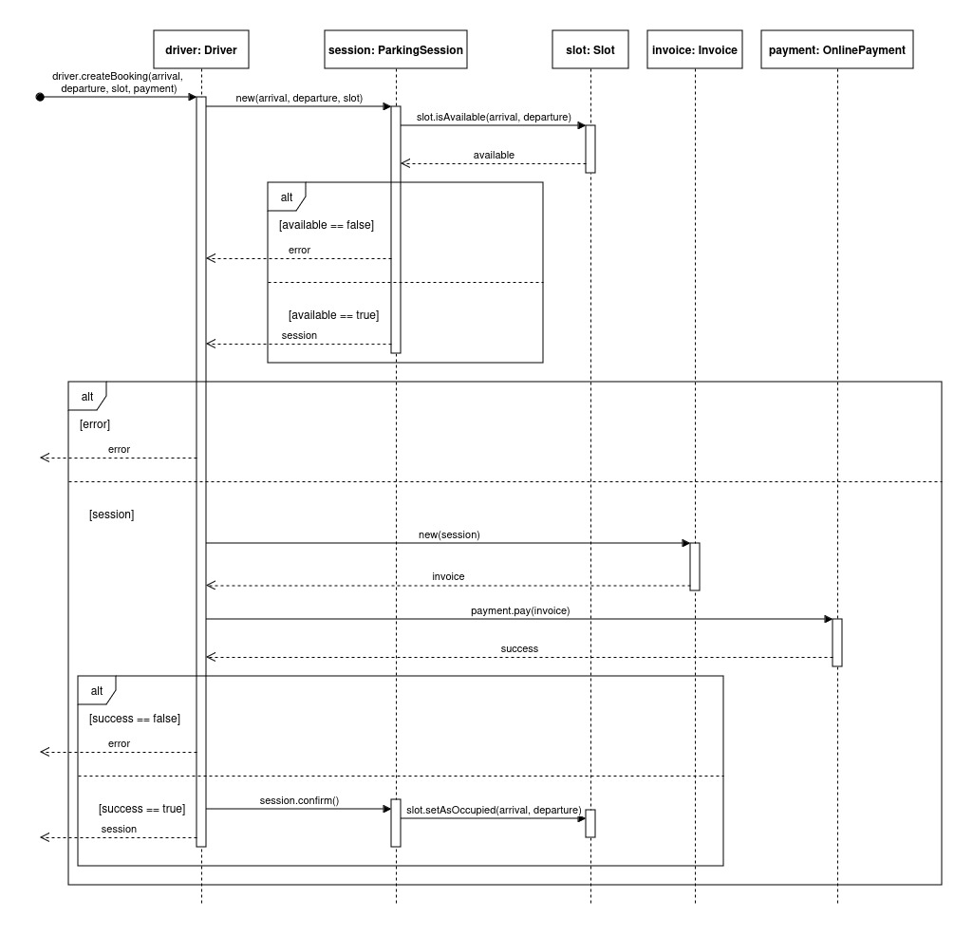
Fig. 3: Pre-book a slot and pay for booking
To begin the booking process, a message is sent to a Driver instance containing the desired parking time, slot, and online payment method. Driver then attempts to create a ParkingSession, which succeeds only if the Slot is available in the specified time period. If it is unavailable, an error is returned. Otherwise, Driver creates a new Invoice instance, passing in the ParkingSession, and then tells the OnlinePayment instance to pay it. Note that OnlinePayment is an abstract class, and in reality an instance of either CreditPayment or OnlineBankingPayment is used here. The payment call returns a boolean flag indicating success or failure. If the payment fails, an error is returned. Otherwise, the parking session is confirmed and the Slot is marked as occupied for the time period.

Park vehicle
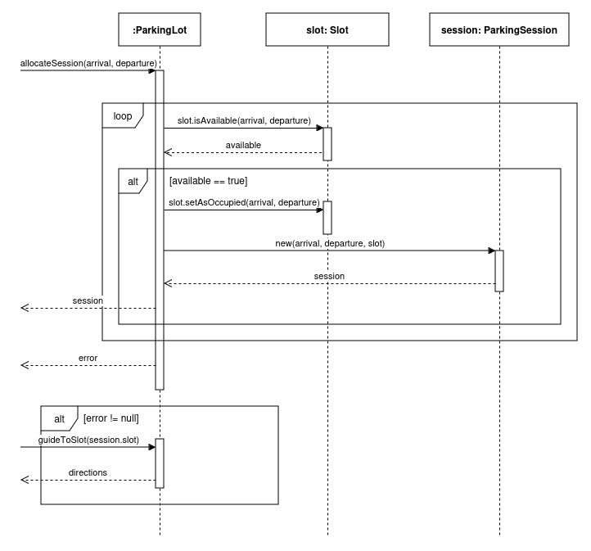
Fig. 4: Park vehicle
When a driver arrives at the parking lot, one of two things can happen. The driver may already have a booking and can drive directly to their slot. However, some drivers may not have booked beforehand and the system must allocate them a slot. The diagram above illustrates this case. The ParkingLot first iterates through all slots and checks if one is available. If none is available, an error is thrown. Otherwise, the available slot is marked as occupied and a new ParkingSession is created and returned to the caller. If the caller receives a ParkingSession, it will send a message to ParkingLot to guide the driver to the slot.

Pay for walk-in
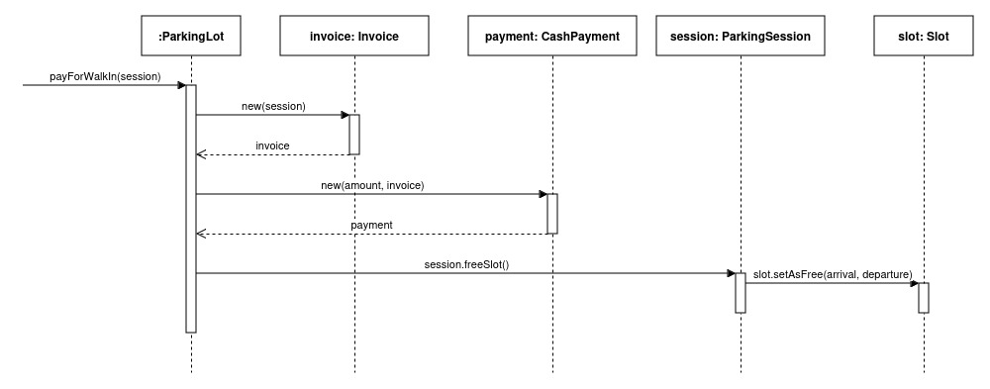
Fig. 5: Pay for walk-in
This scenario illustrates the payment process for walk-in drivers. First, a message is sent to ParkingLot containing the ParkingSession to pay for. Then, an Invoice is generated for this session. Next, ParkingLot creates an appropriate Payment object based on the driver’s payment option. In this example, CashPayment has been chosen by the driver. After the payment is complete, ParkingLot tells ParkingSession to free the Slot for future parkers.

View parking lot statistics
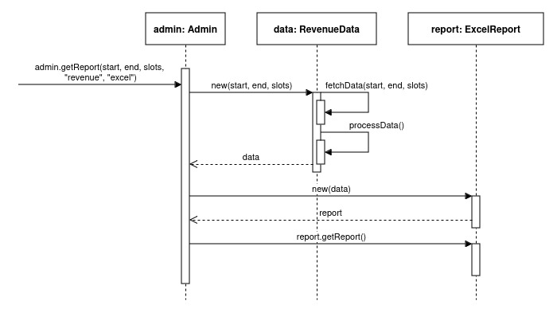
Fig. 6: View parking lot statistics
To view the parking lot statistics, a message specifying the data type and format is first sent to an Admin instance. Admin then creates the appropriate ReportData and Report instances based on the data type and format, respectively. In this diagram, RevenueData and ExcelReport have been chosen by the caller. ExcelReport receives the RevenueData and generates the output when the getReport() method is called. At this level, we assume that this method prints the formatted output to a file, in this case an Excel file.

Appendix
Attached on the remainder of the pages is the Requirement Specifications that this document was based on.

